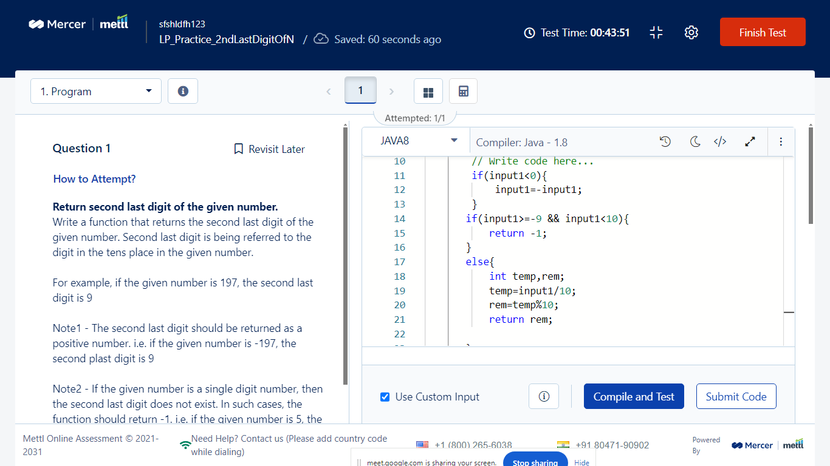

Q2. Write a java program to print sum and average of all array elements?

Array Elements: 10 20 30 40 50

Sum: 150

Average: 30

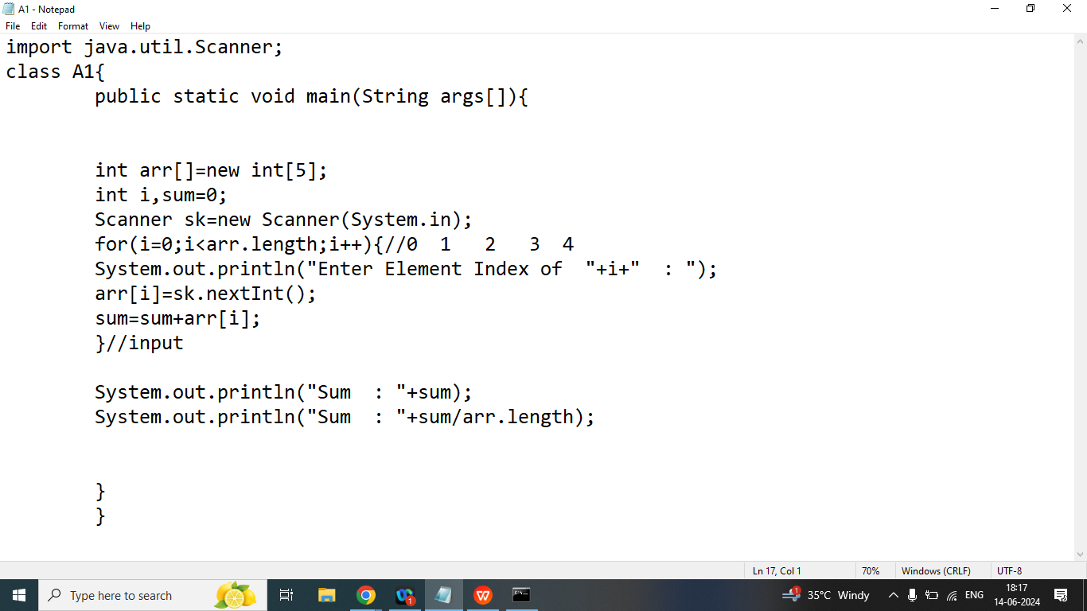

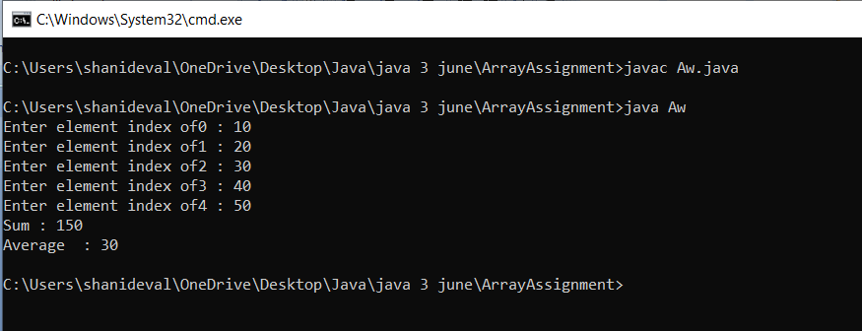

Q2. Write a java program to print sum of all even elements of the array

Array Elements: 10 21 32 41 51

Sum of All Even Elements : 42

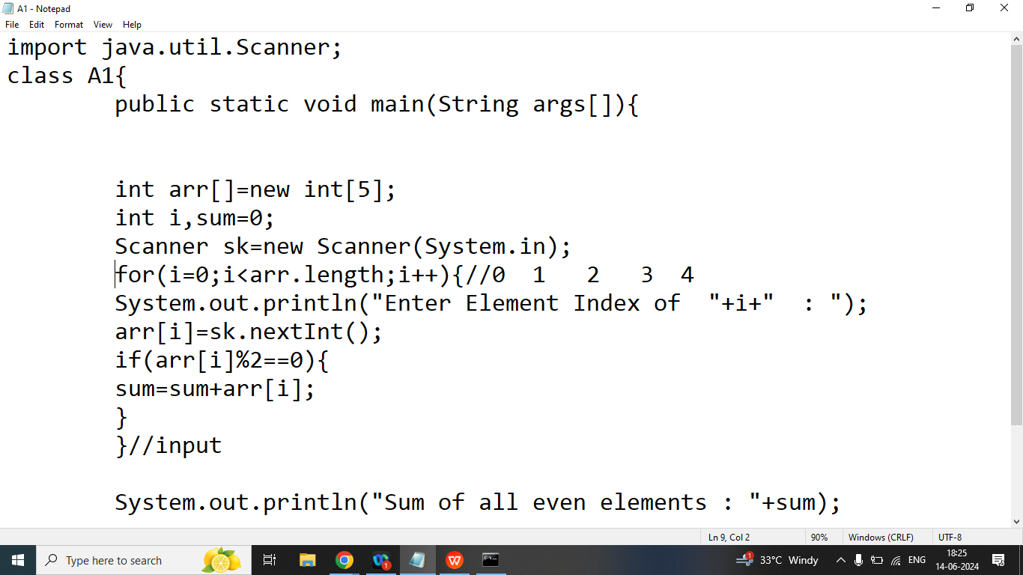

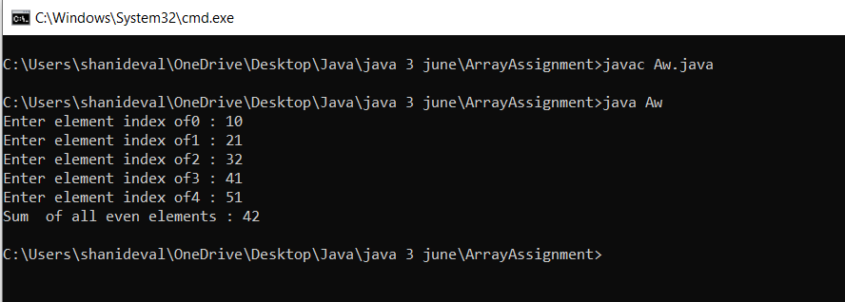

Q2. Write a java program to print sum of all odd elements of the array

Array Elements: 10 21 32 41 51

Sum of All odd Elements : 113

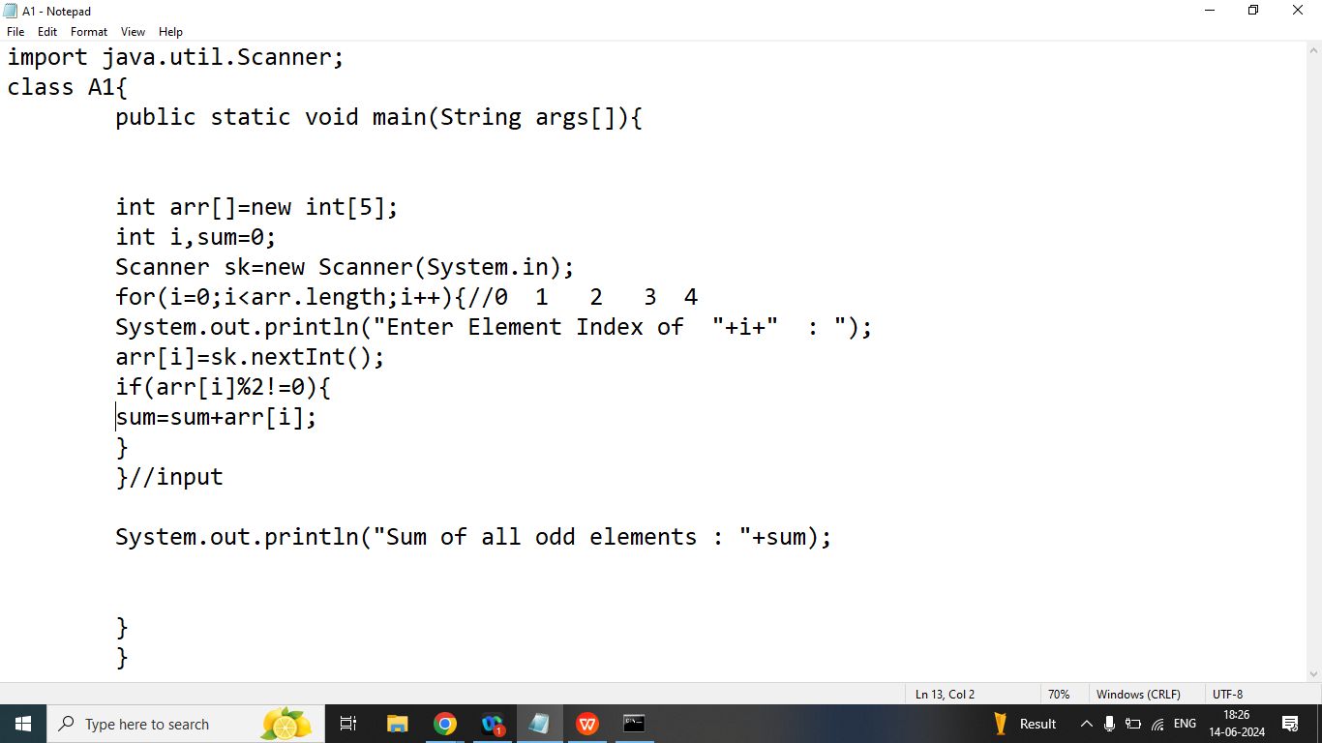

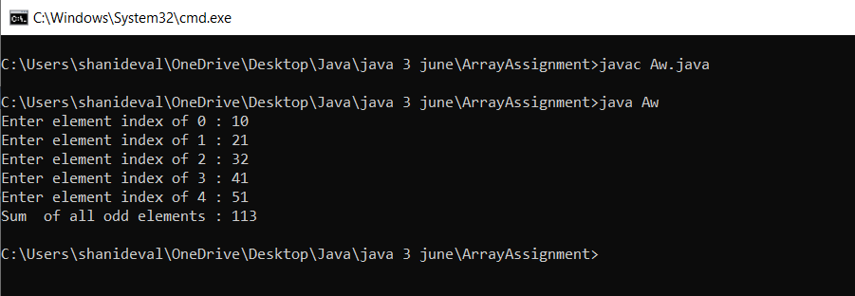

Q3. Write a java program to print all array elements in reverse order

Array Elements: 10 20 30 40 50

Reverse Oder: 50 40 30 20 10

